**Project Design Phase-II**

**Technology Stack (Architecture & Stack)**

|  |  |
| --- | --- |
| Date | 31 January 3035 |
| Team ID | LTVIP2026TMIDS77573 |
| Project Name | Explore with AI: Custom Itineraries for Your Next Journey |
| Maximum Marks | 4 Marks |

**Technical Architecture:**

The Deliverable shall include the architectural diagram as below and the information as per the table1 & table 2

**Technical Architecture – TravelGuideAI**

The technical architecture of TravelGuideAI is designed to provide a smooth and intelligent travel itinerary generation experience. The system integrates a user-friendly frontend with a powerful Generative AI backend.

The architecture consists of three main layers:

**1️⃣ Frontend Layer (User Interface)**

The frontend is developed using **Streamlit**, which allows users to enter travel details such as destination, number of days, and number of nights. The interface is simple, interactive, and accessible through a web browser.

**2️⃣ Application Logic Layer**

This layer processes user inputs and formats them into structured prompts. It handles validation, request formatting, and communication between the frontend and the AI model.

**3️⃣ AI Processing Layer**

The Generative AI model (Gemini) analyzes the user’s inputs and generates a personalized travel itinerary. The model creates structured outputs including daily plans, attractions, and dining suggestions.

The generated itinerary is then sent back to the Streamlit interface for display to the user.

**Example: Order processing during pandemics for offline mode**

**Reference:** [**https://developer.ibm.com/patterns/ai-powered-backend-system-for-order-processing-during-pandemics/**](https://developer.ibm.com/patterns/ai-powered-backend-system-for-order-processing-during-pandemics/)

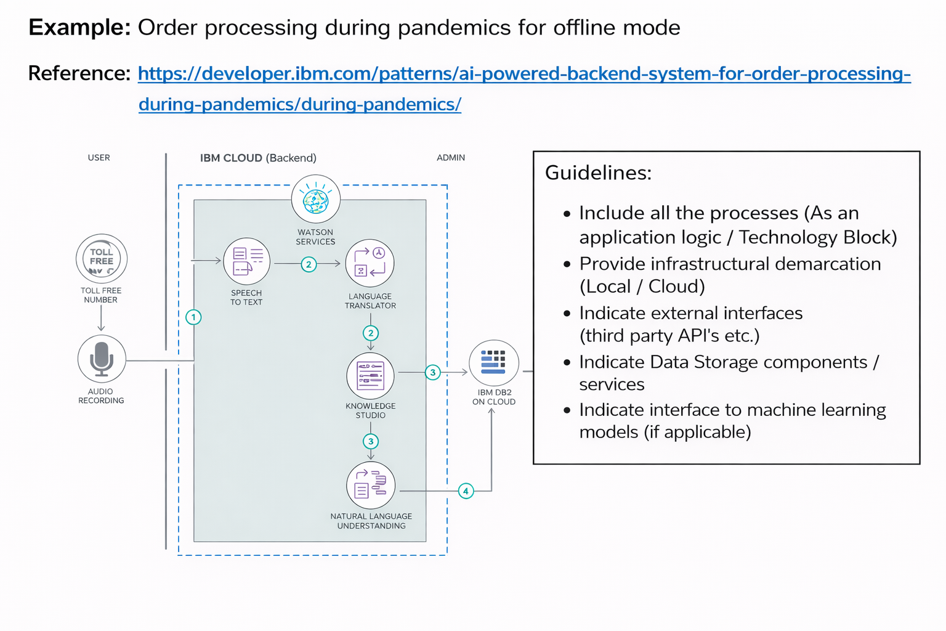

**Table-1 : Components & Technologies:**

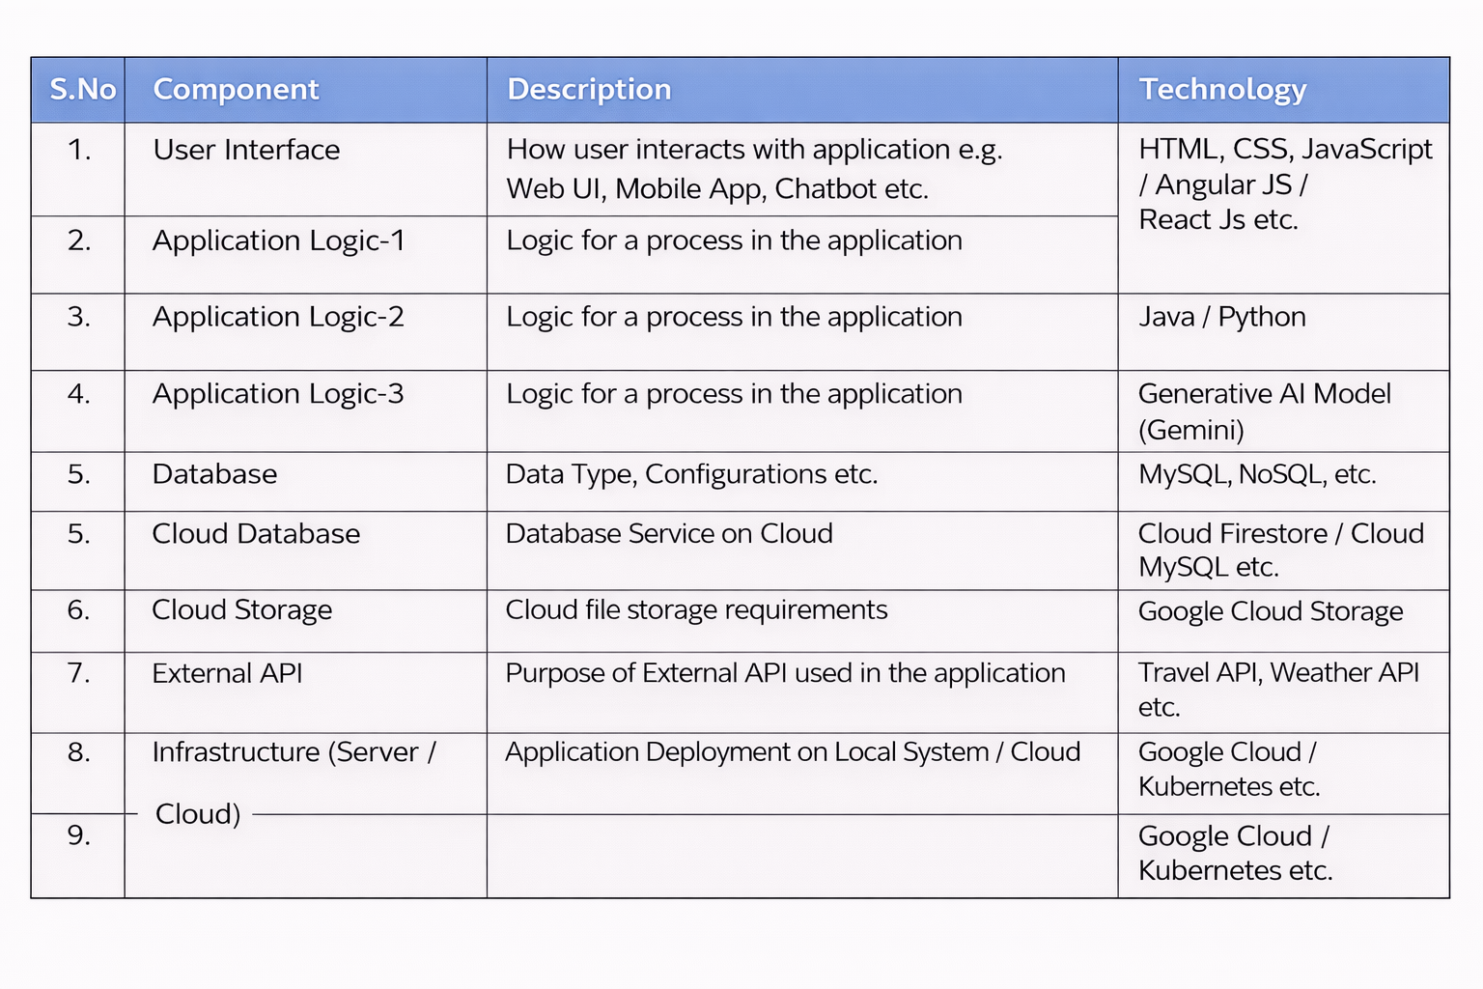

**Table-2: Application Characteristics:**

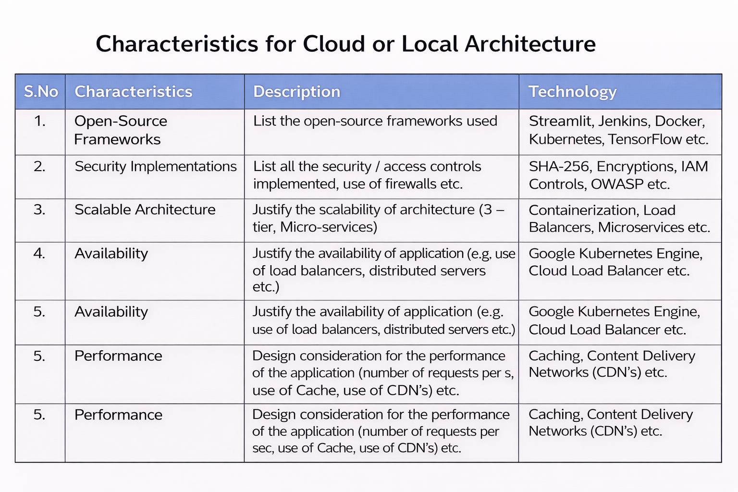

**References:**

[**https://c4model.com/**](https://c4model.com/)

[**https://developer.ibm.com/patterns/online-order-processing-system-during-pandemic/**](https://developer.ibm.com/patterns/online-order-processing-system-during-pandemic/)

[**https://www.ibm.com/cloud/architecture**](https://www.ibm.com/cloud/architecture)

[**https://aws.amazon.com/architecture**](https://aws.amazon.com/architecture)

[**https://medium.com/the-internal-startup/how-to-draw-useful-technical-architecture-diagrams-2d20c9fda90d**](https://medium.com/the-internal-startup/how-to-draw-useful-technical-architecture-diagrams-2d20c9fda90d)